|  |
| --- |
| Universitat Pompeu Fabra |
| Mobile Node. Detailed documentation |

|  |
| --- |
| Fernando Gros González  3/27/2013 |

# Table of Contents

Table of Contents 1

What is the Mobile Node? 2

How was it born? 2

What for? 2

Related texts 3

Component Description 4

Hardware 4

Software 7

Types of Mobile Nodes 7

Assembly 9

Box drilling and pigtail installation 9

Installation of the board 9

Installation of the radios 10

Connection of the pigtails to the radios 10

Installation of the flash card and switching-on 11

Implementation 12

Configuration of the nodes 14

Nanostation M5 14

Rocket M5 15

Alix 2D2 15

Basic features of the QMP interface 16

Status tab 17

Mesh tab 18

Configuration tab 19

Tools tab 20

# What is the Mobile Node?

The mobile node is a portable and auto-configurable transmission unit with wireless technology that offers mobility in the urban space. This node is designed to contribute to the digital mesh through existing networks. Furthermore, it provides connectivity with a wide range of different hardware: fix nodes, other mobile nodes, smartphones, pc, tablets, etc.

## How was it born?

The basic idea that lies behind the concept of the mobile node, is the socialization and modeling of the networks according to the interests and needs of communities and citizens, completely changing the paradigm. At present, networks are designed and deployed based on corporate and/or government interests, this fact does not allow the home user to control its data flows and, much less, get involved in the process.

Thanks to the low costs of the equipments and to the fact that they are completely self-configuring, it is now possible to model the urban space based on people or communities who are the ones that will be using these infrastructures. It allows users to take part in the process from beginning to end, from bottom to top. Thus, the city and the data flows that govern it will be totally adapted to people, breaking the barriers that are currently imposed by the well established designs we have to deal with.

## What for?

The access to independent and self-managed transmission channels in the public space has very high associated costs. Most communities are unable to meet these expenses and therefore, they cannot increase their representativeness within the society controlling their traffic. At this point, is where the project is intended to emphasize. Using bottom-up models we try to respond to this necessity by creating a new concept of “social routing” agreed on consensus, with open protocols that provide access to the physical and digital public space. This configuration, offers a model with low costs, high social representativeness and ease of reproduction.

## Related texts

Foglia, E. (2011). Colisiones en la MediaCity, Prácticas sociales y artísticas sobre el trazado digital. En: Impresión Expandida / Expanded Print. (ed.) Eloi Puig, Alicia Vela y Antonia Vilà. ED: Barcelona, Universidad de Barcelona.  
  
Foglia, E. (2010). Mobile Node: Open Portable Infrastructure, Overlapping Digital Paths. MediaCity: Interaction of Architecture, Media and Social Phenomena. ED: Weimar, Bauhaus-Universität.

# Component Description

## Hardware

Below there is a list of the components that form the mobile node and the other nodes that make possible to create mesh networks and its main features:

* Ubiquiti Airmax Bullet M5:
  + Description: Wireless outdoors device that transmits in the 5GHz band.
  + Details:
    - Protocols: 802.11a, 802.11n
    - Outdoor range (depending on the antenna): more than 50km
    - Transmission Frequency: 5470MHz-5825MHz
    - Maximum transmitted power: 27 dBm
    - Bandwidth: Until 100Mbps
* Ubiquiti Nanostation M5:
  + Description: Outdoors CPE (*Customer Premises Equipment*) device that transmits in the 5GHz band.
  + Details:
    - Protocols: 802.11a, 802.11n
    - Outdoor range: more than15km
    - Transmission Frequency: 4900-5800MHz
    - Maximum transmitted power: 27 dBm
    - Bandwidth: Until 150Mbps
* Ubiquiti Aircam dome:
  + Description: IP cammera Ethernet cable supplied.
  + Details:
    - Supported protocols: IPv4/v6, HTTP, UPnP, DNS, NTP, RTSP, DHCP, TCP, UDP, IGMP, RTCP, ICMP, ARP
    - Image quality: 30 FPS, HDTV 720p
    - Video compression:  H.264/MPEG-4/MJPEG
* Ubiquity Aircam mini:
  + Description: IP cammera Ethernet cable supplied.
  + Details:
    - Supported protocols: IPv4/v6, HTTP, UPnP, DNS, NTP, RTSP, DHCP, TCP, UDP, IGMP, RTCP, ICMP, ARP
    - Image quality: 30 FPS, 1MP/HDTV 720p
    - Video compression:  H.264/MPEG-4/MJPEG
* Arduino DUE:
  + Description: Electronic board based on a core ARM 32-bit processor that enhances the standard Arduino functionalities.
  + Details:
    - Microcontroller: AT91SAM3X8E
    - Digital I/O pins: 54 (12 have PVM output)
    - Analog input pins: 12
    - Analog output pins: 2
* Arduino WiFi Shield:
  + Description: Board that connects an Arduino to the Internet wirelessly.
    - Protocols: 802.11b, 802.11g
    - Encryption types: WEP y WPA2
* 2 batteries: Rechargeable Li-ion Emergency Power Battery:
  + Description: Battery for video camera, walkie talkie, camera, etc.
    - Capacity: 9000mAh
    - Input voltage: 12.6V
    - Output voltage: 12V
* 2 black passive screwable POE modules:
  + Description: It supplies electrical power to the device through an Ethernet port that supports PoE.
    - Connector: Ethernet RJ-45
    - Bandwidth: 10/100 Mbps
* Network cable and Ethernet RJ-45 connectors:
  + Description: Wire and connectors to assemble direct and crossover Ethernet cables.
* Female faston connectors:
  + Description: Connectors to be added to an electrical wire.
* **Box with IP65 antenna:**
  + **Description: Outdoor compact case with an integrated antenna that operates across the 5GHz band**.
  + Details:
    - Transmission frequency: 4900MHz-5900MHz
    - Maximum Gain: 20 dBi
* PC Engines ALIX 2D2:
  + Description: Low power computer board:
  + Details
    - Memory: 256 MB DDR DRAM
    - Processor: 500 MHz AMD Geode LX800
* Compex radio:
  + Description: Compact radio with a high performance and a low power consumption.
    - Transmission frequency: 2,4GHz y 5GHz
    - Protocols: 802.11 a/b/g/n
    - Chipset: Atheros AR5414
* Pigtail 15cm. UFL/N-H (female) Bulkhead:
  + Description: Connector good for most of Mini-PCI radios.
  + Details:
    - Connector type: UFL (IPEX, Hi-Rose) to N Female Bulkhead.
* Pigtail 5 GHz. UFL-SMA plug right angle 30 cm:
  + Description: Connector for box-integrated antennas and most of Mini-PCI radios.
  + Details:
    - Connector type: UFL (IPEX, Hi-Rose) to SMA right angle.
* Power supply 18v. 0,8 A (15 W) Alix 2C/3C):
  + Description: Switching power supply unit for Ubiquiti devices, Alix boards, etc.
* DMD: Dot Matrix Display
  + Description: LED panel that easily displays clocks, status screens, graphs, etc. Compatible with Arduino.

## Software

The software used by the mobile node is a firmware called Quick Mesh Project (QMP). It is a GNU/Linux operating system based on OpenWRT for embedded devices. The main features of this firmware are:

* OpenWRT based
* 802.11a/b/g/n support
* IPv6 native
* IPv4 tunneled over IPv6
* Auto configuration system
* Web GUI to monitor and configure
* Visualization tools (maps, graphs, etc.)
* Automatic dynamic routing (zero-conf)
* BGP (Border Gateway Protocol) support (half implemented)
* Open Source

## Types of Mobile Nodes

Due to the different needs identified during the development process of the prototypes, it was decided to create four different design options. Each with its own characteristics:

1. **Panzer**. Robust with a large electronic box which can hold more batteries. It has greater stability. 4 wheels.
2. **Tarantula**. Lighter than Panzer. It has extendable legs for stability. 4 wheels.
3. **Trip**. Special for trips. Based on existing plastic boxes. Tracker wheels very robust and computer equipment container.
4. **Cam**. Wireless high definition video camera which interconnects with mobile nodes. Lightweight and with the possibility of streaming video.

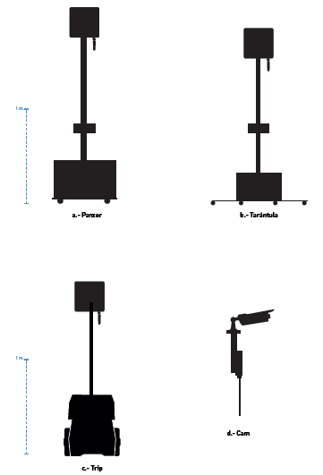

# Assembly

We will divide the process in several steps

Box drilling and pigtail installation

The following pictures show the process:

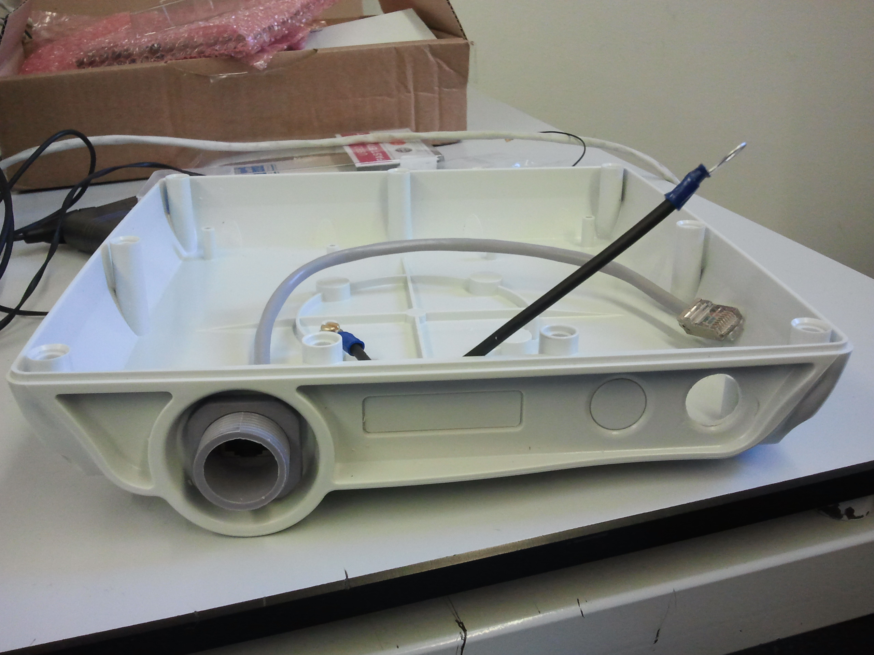

Drilled box

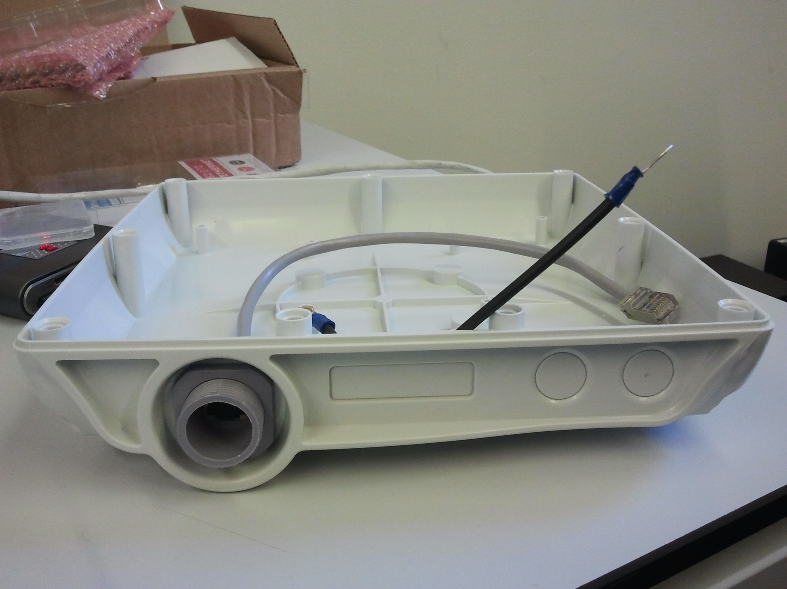

Undrilled box

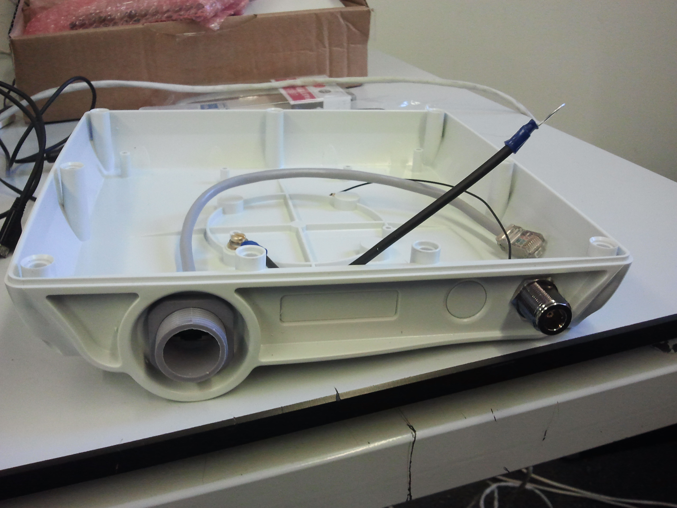

Box with pigtail installed

For this process, it is necessary a drill (or similar) to perforate the box and a cutter (or similar) to scratch and remove the remaining burr.

Installation of the board

It basically consists on adhere and affix the board to the box.

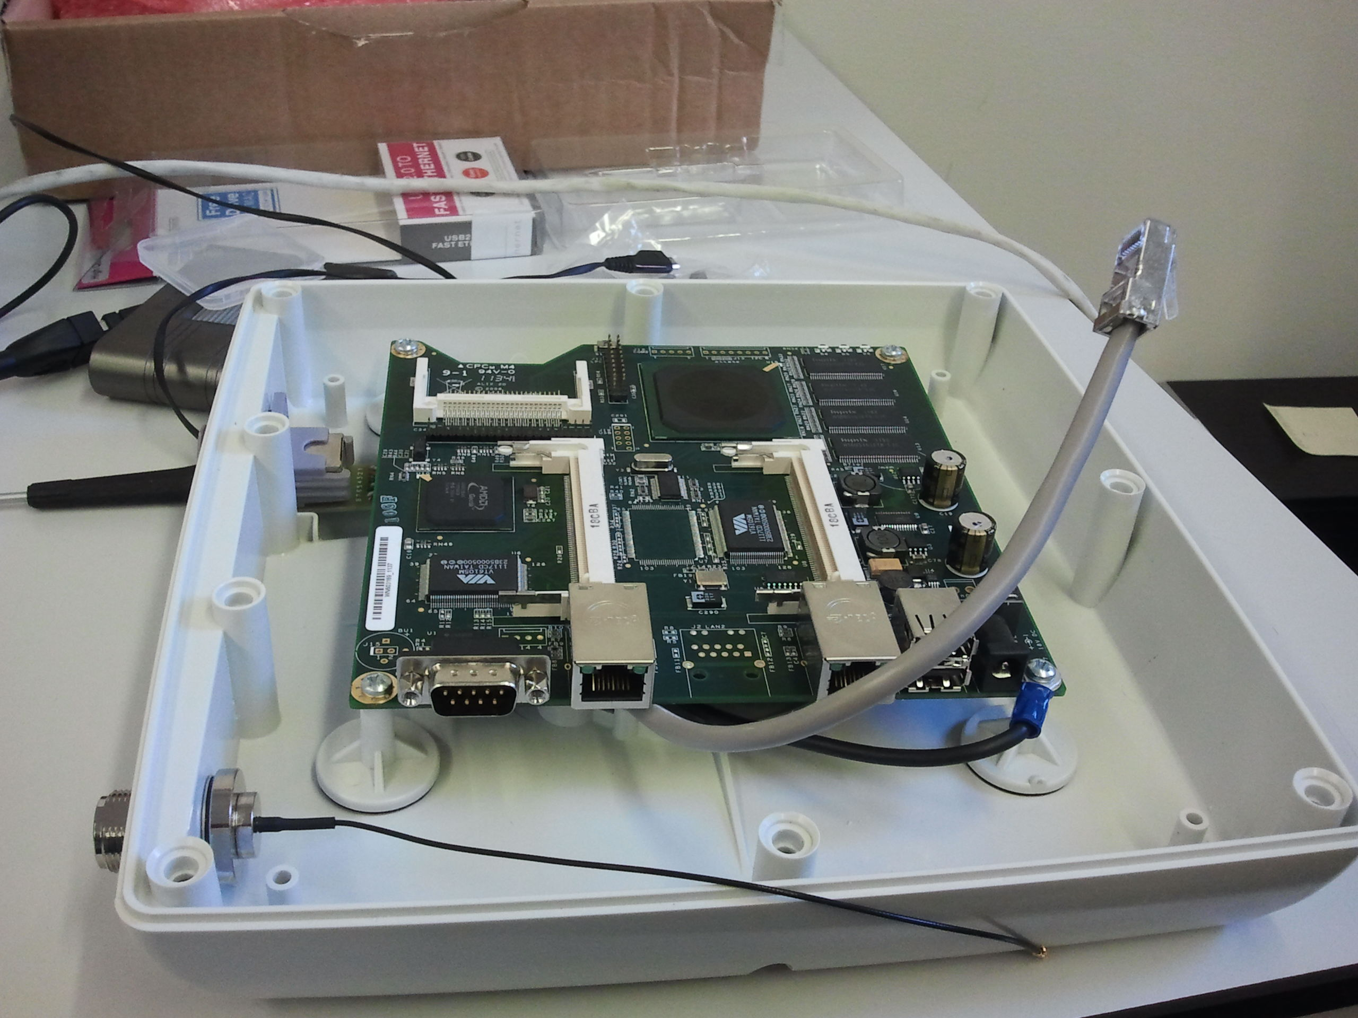

Orientation and location of the board in the box

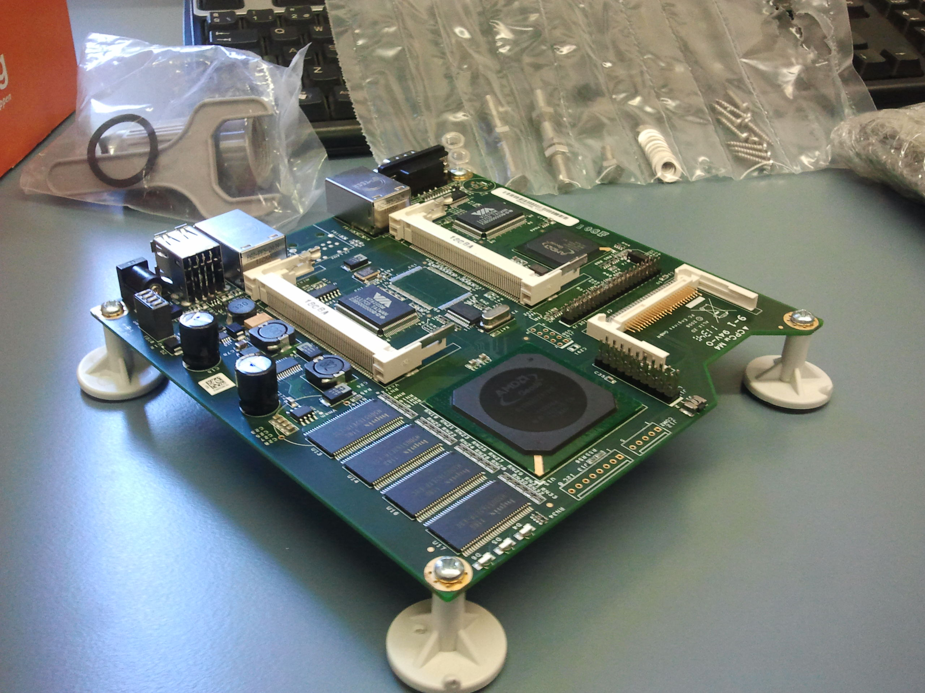

Affix the brackets to the board

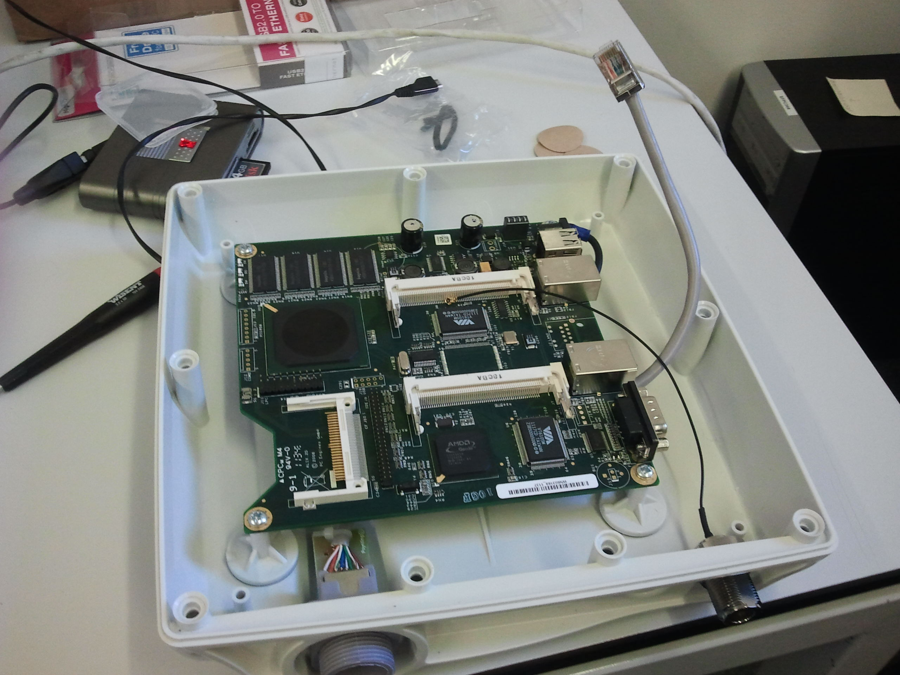

Board affixed and wires orientation

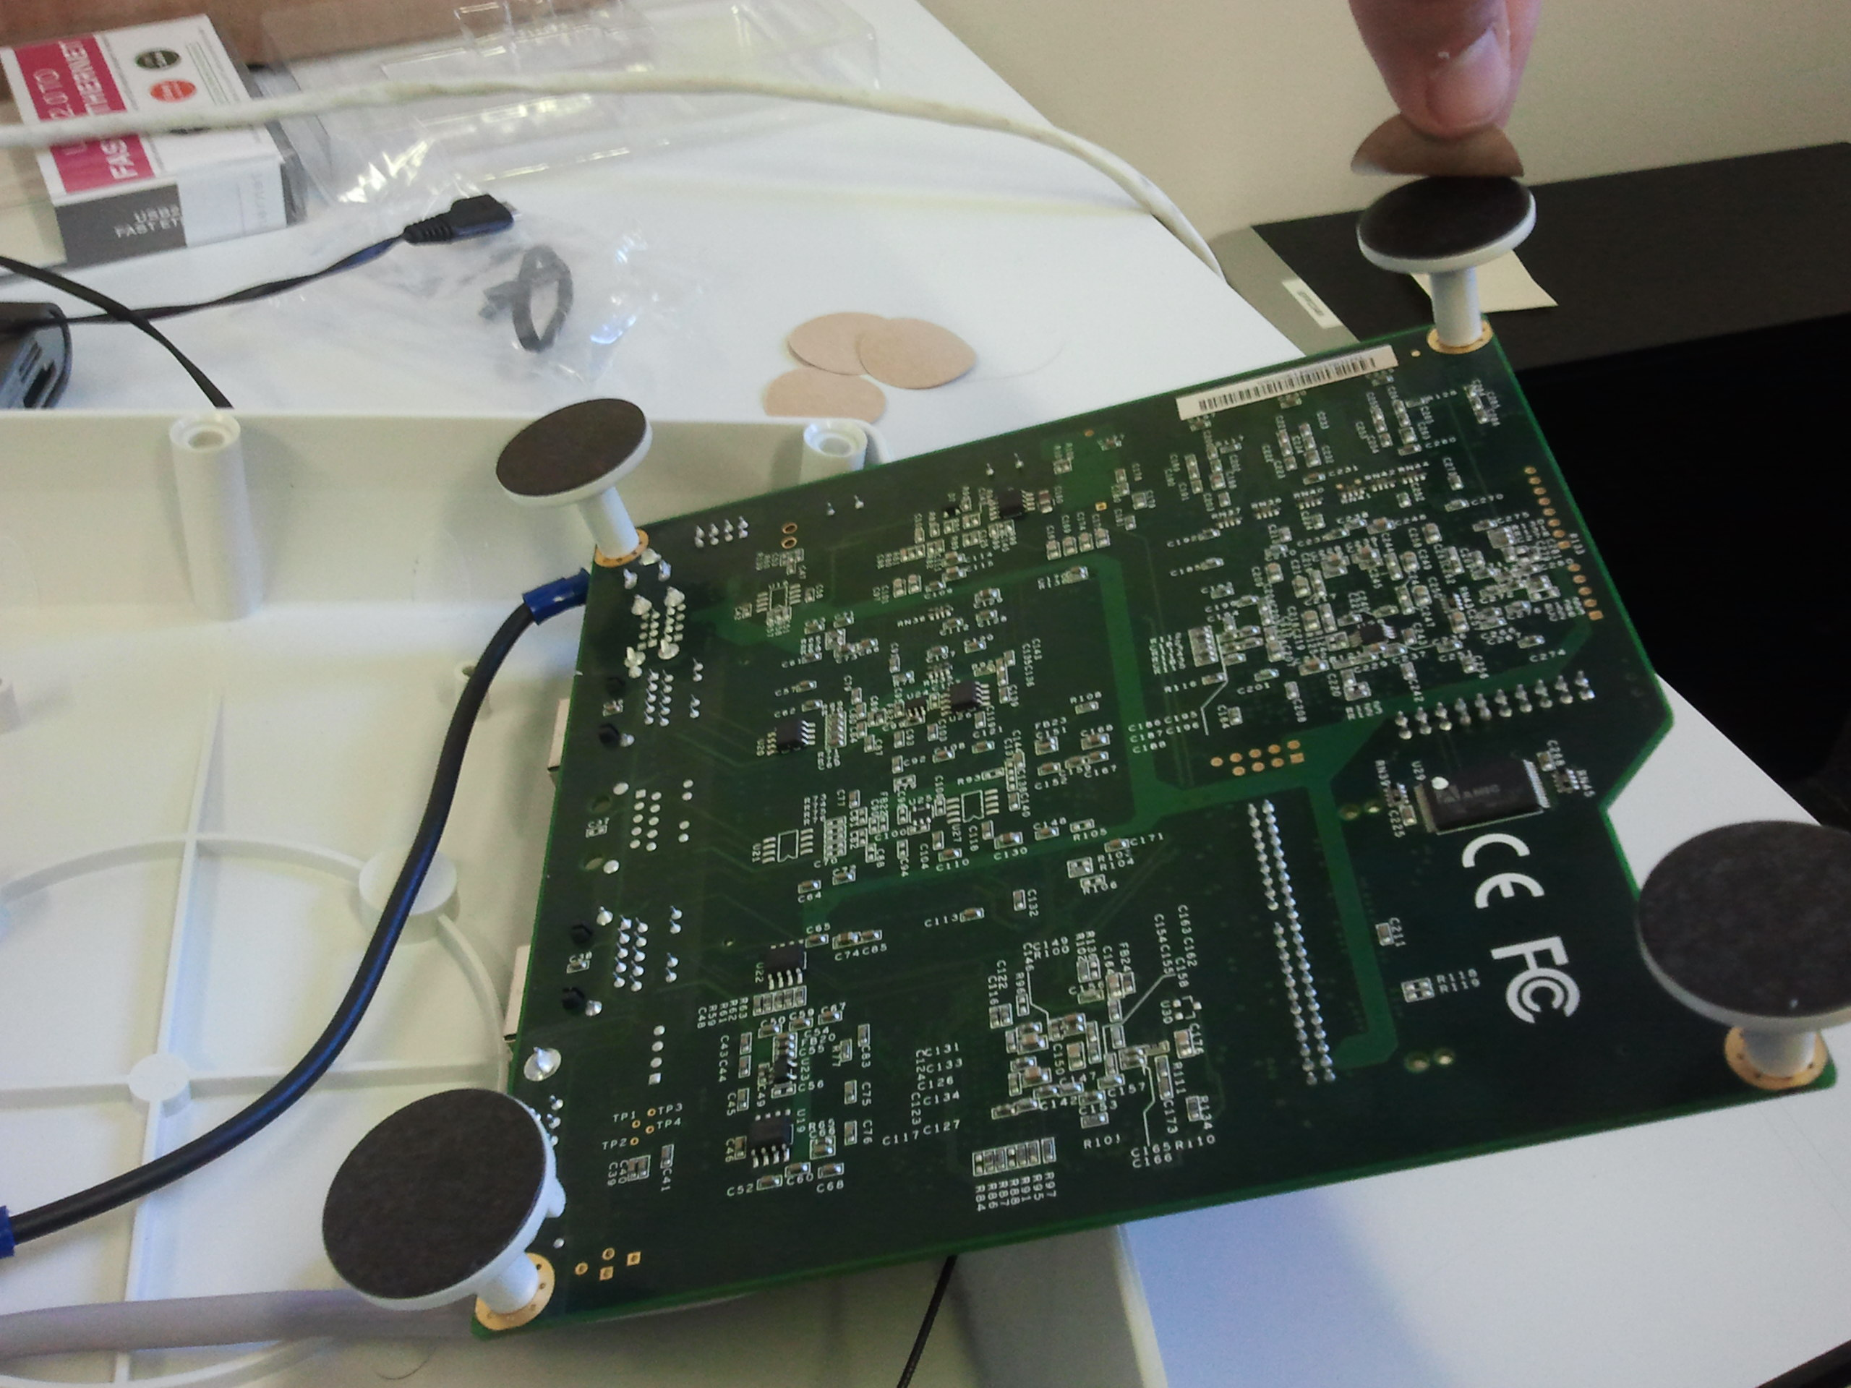

Remove the protectors of the brackets

For this process it is simply necessary a screwdriver.

## Installation of the radios

Fit the radios into the appropriate slots of the motherboard:

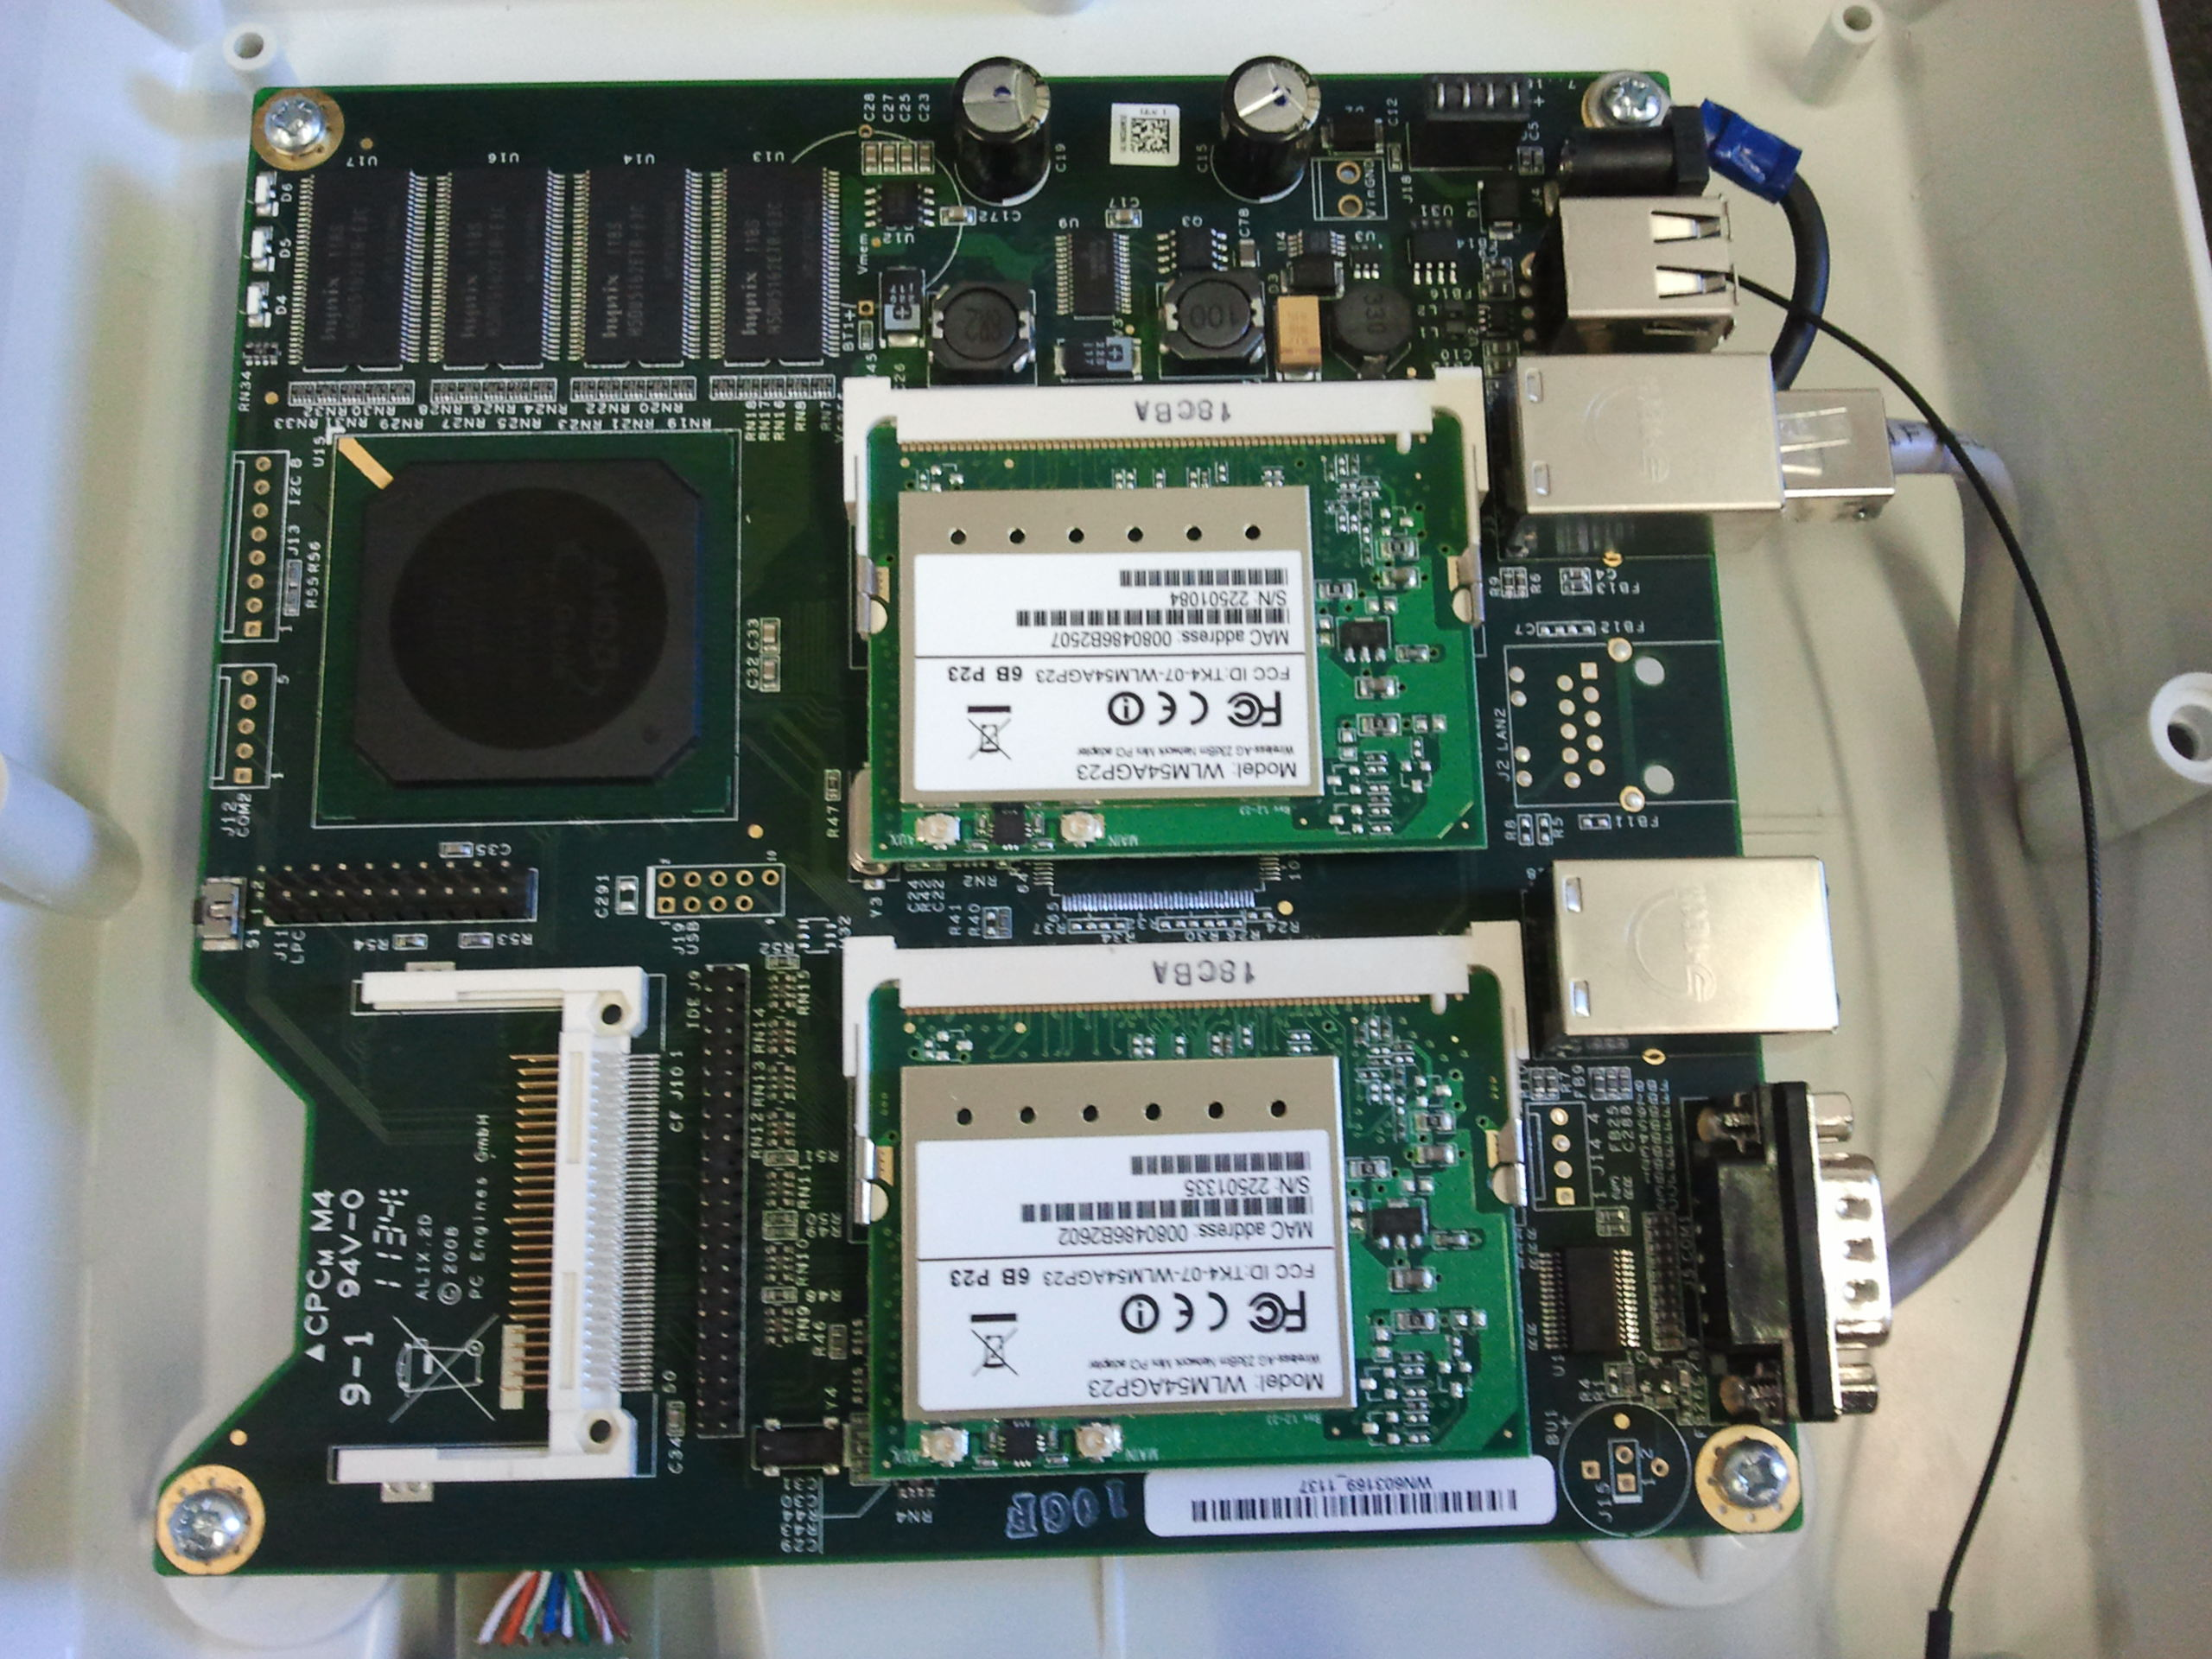

Radios installed on the board

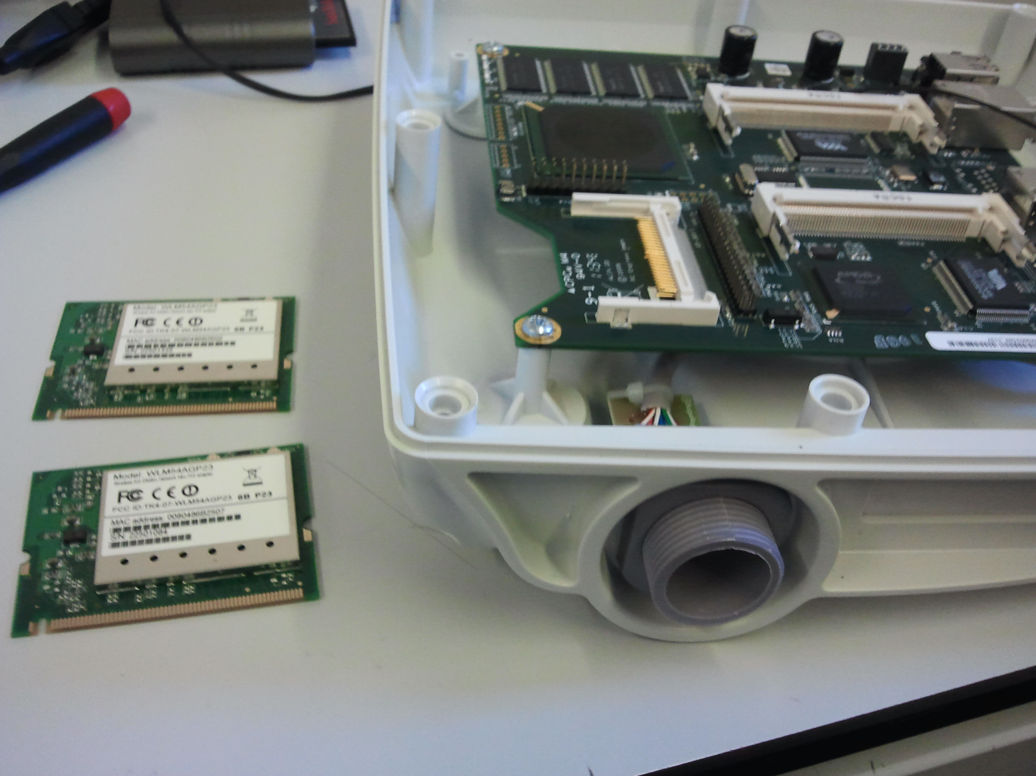

Compex radios

## Connection of the pigtails to the radios

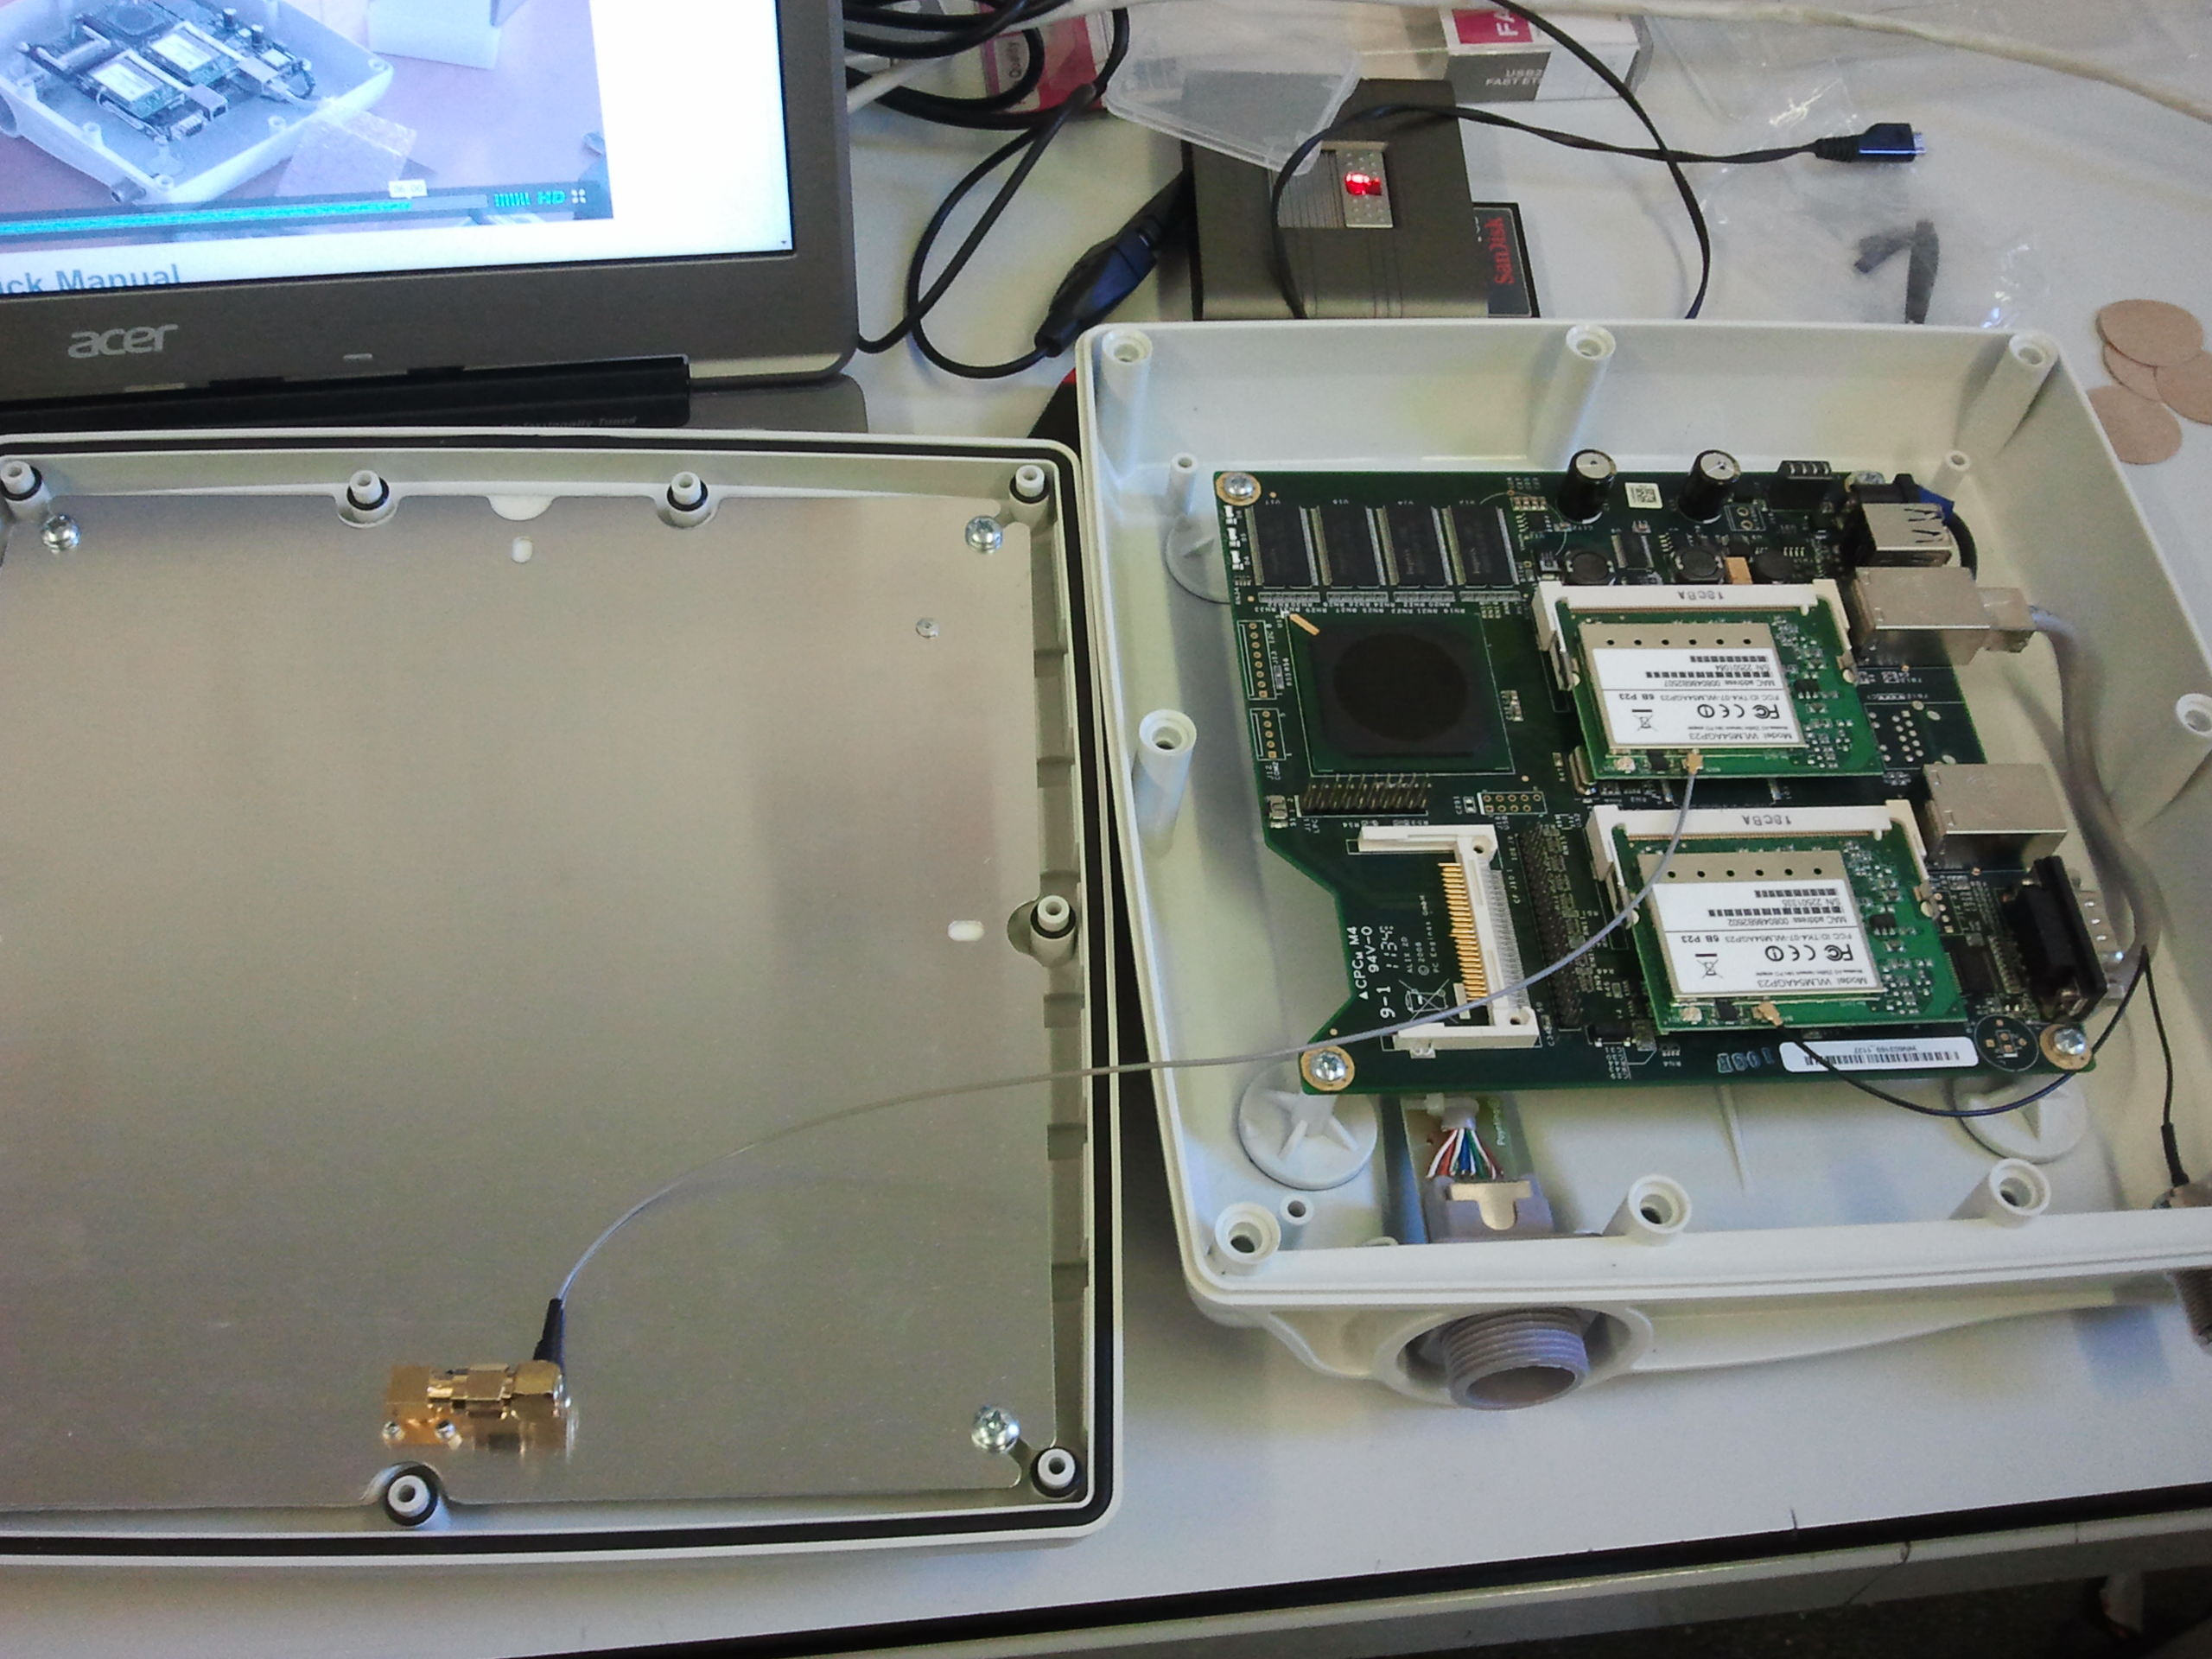

Pigtail connected to the upper cover of the box (antenna)

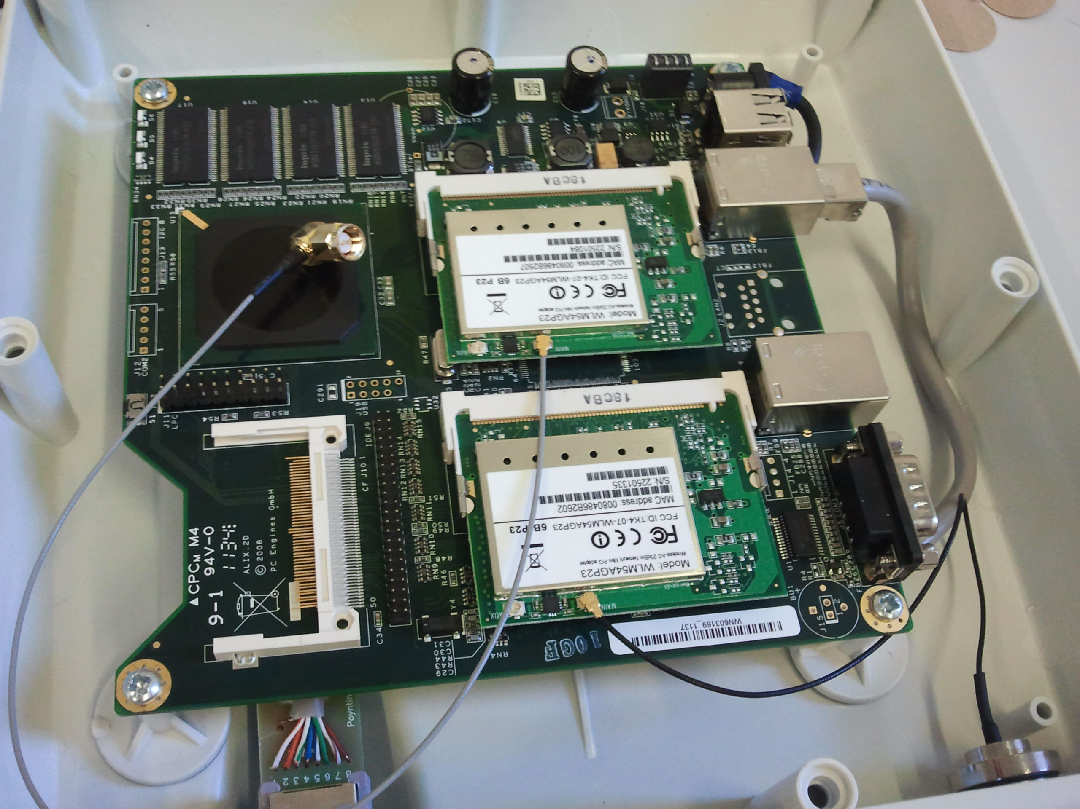

Pigtails connected to the radios

## Installation of the flash card and switching-on

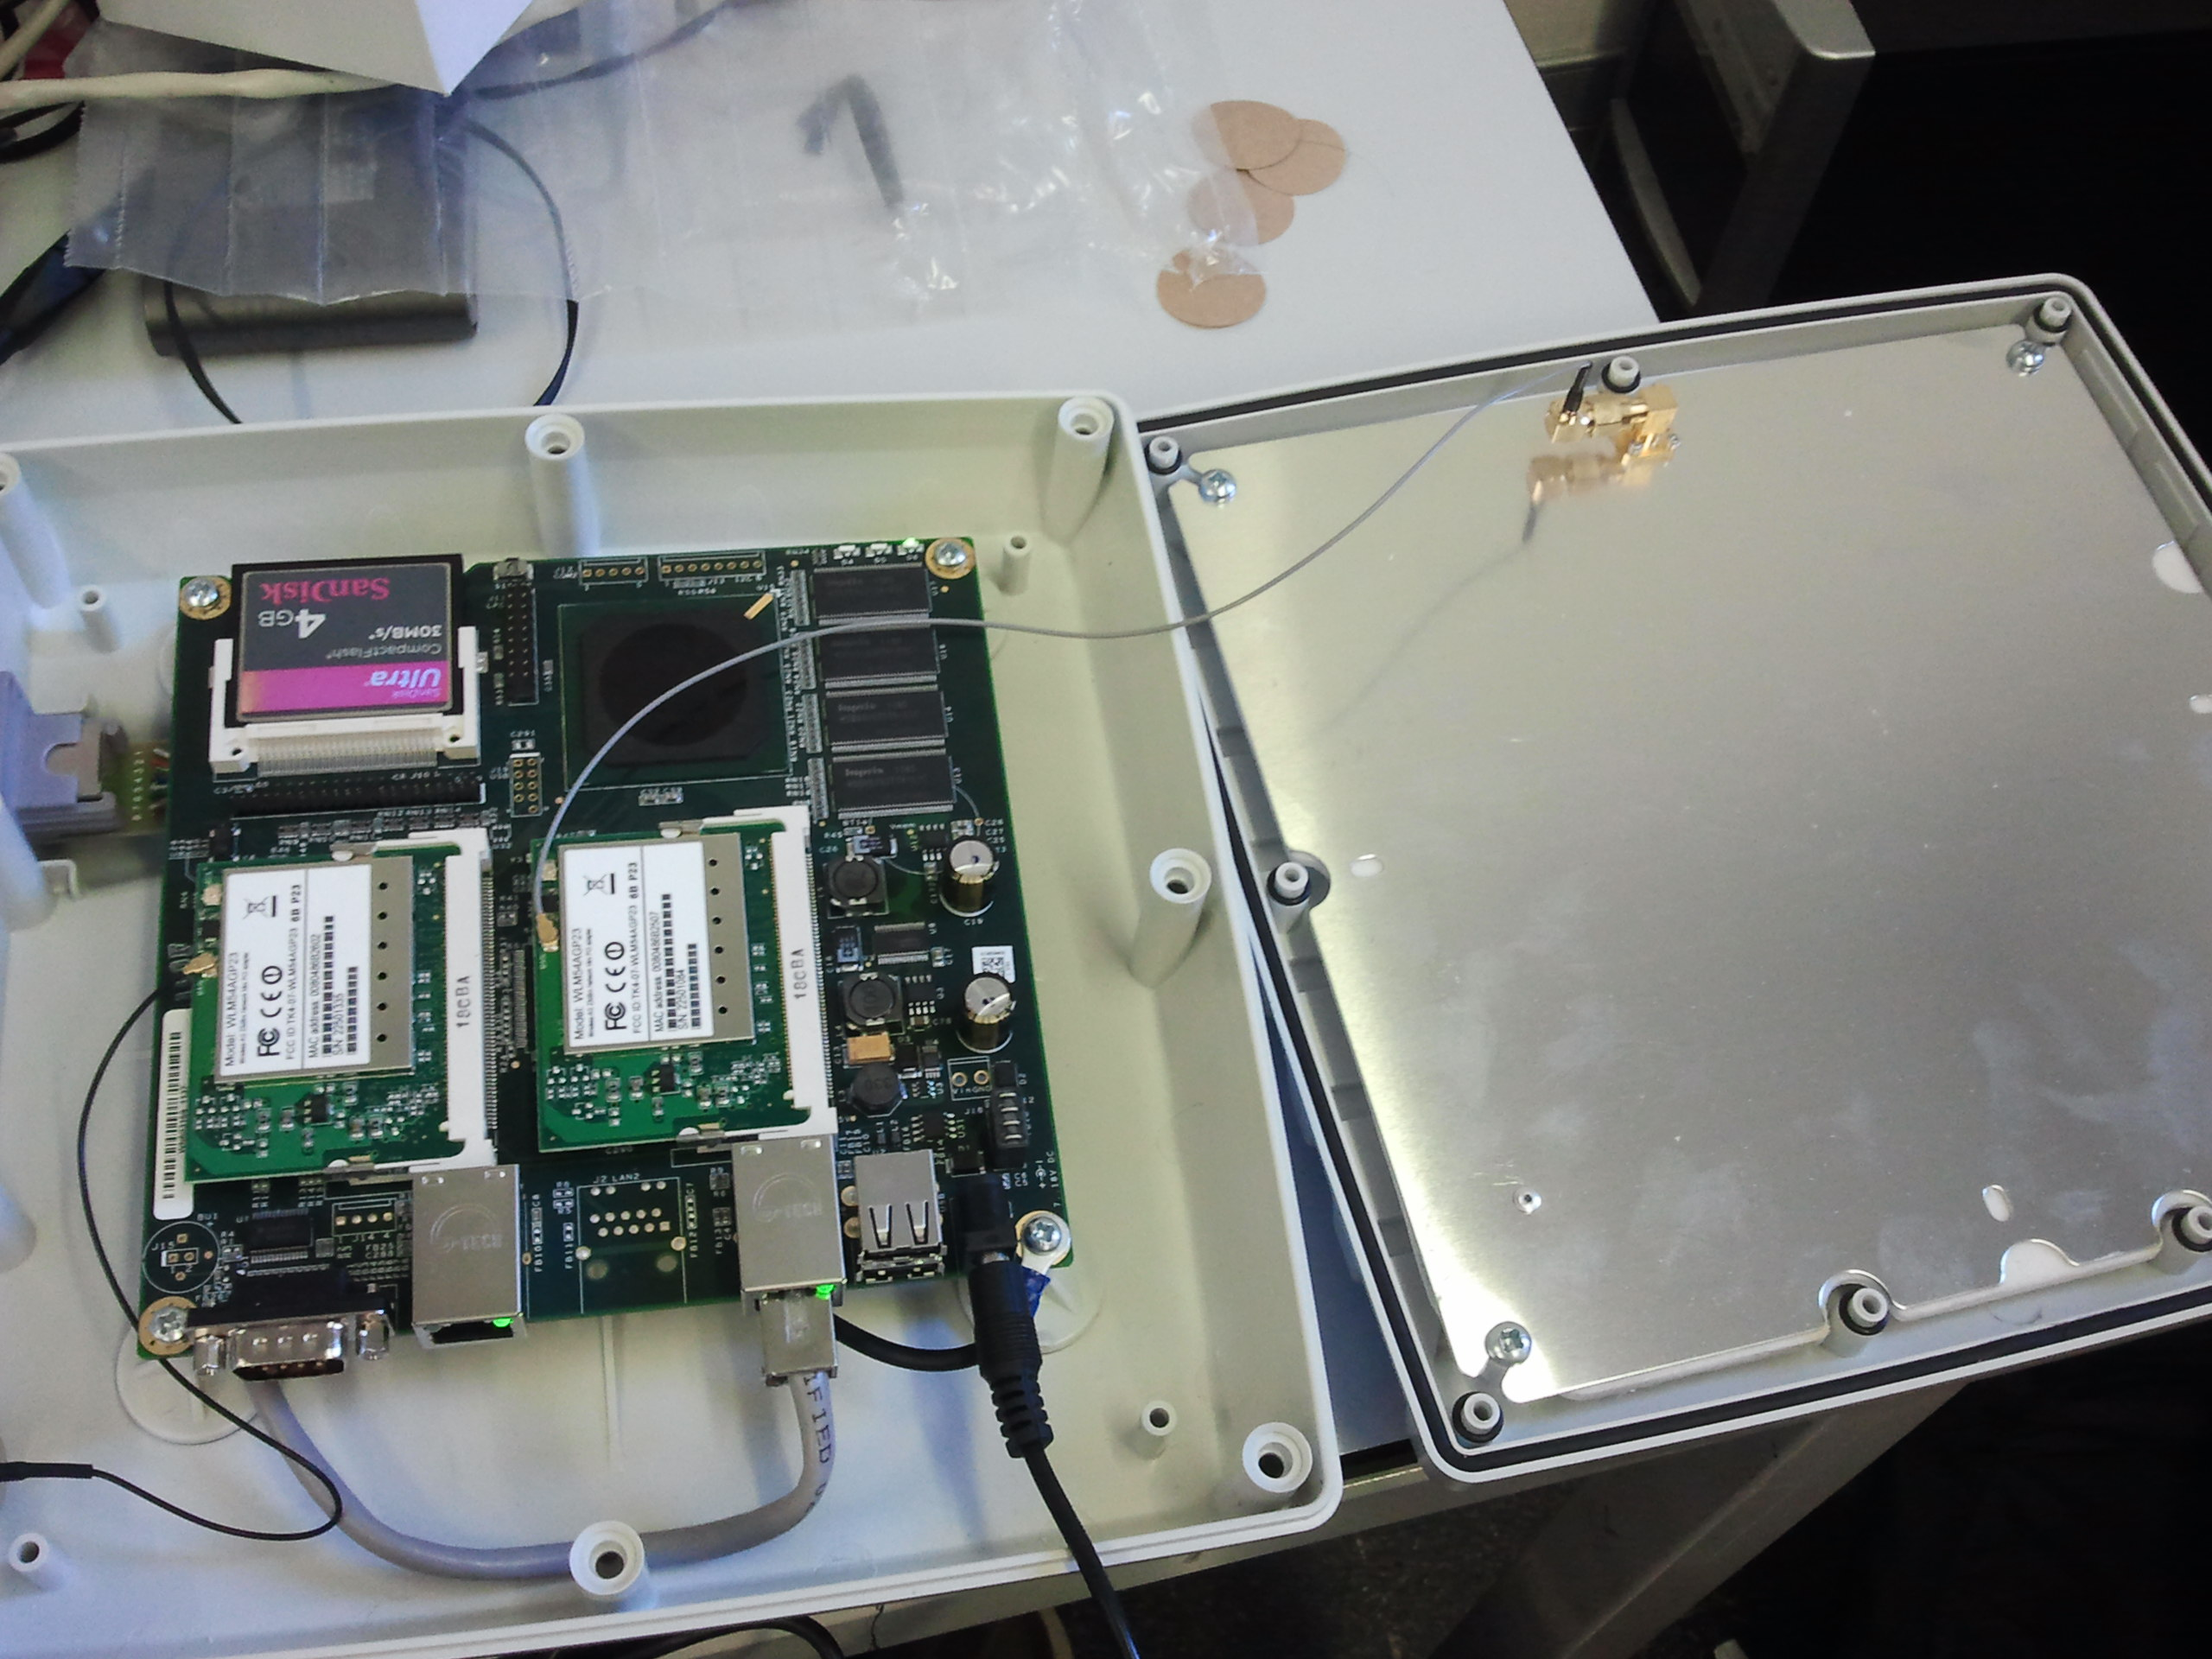

Power supply connected

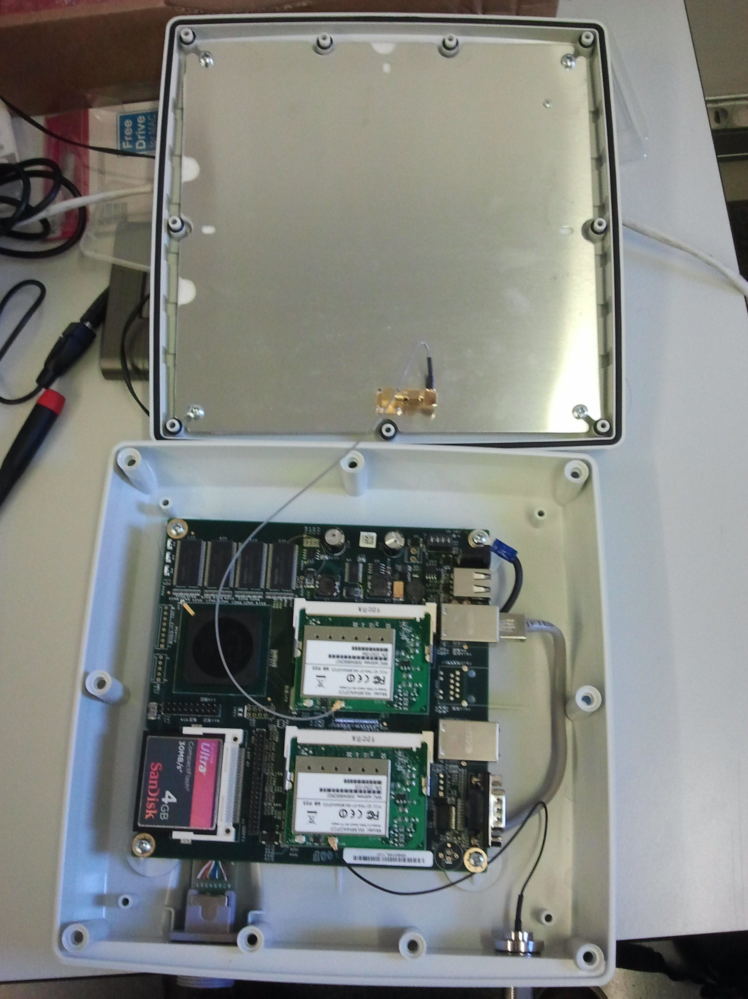

Card inserted into the slot

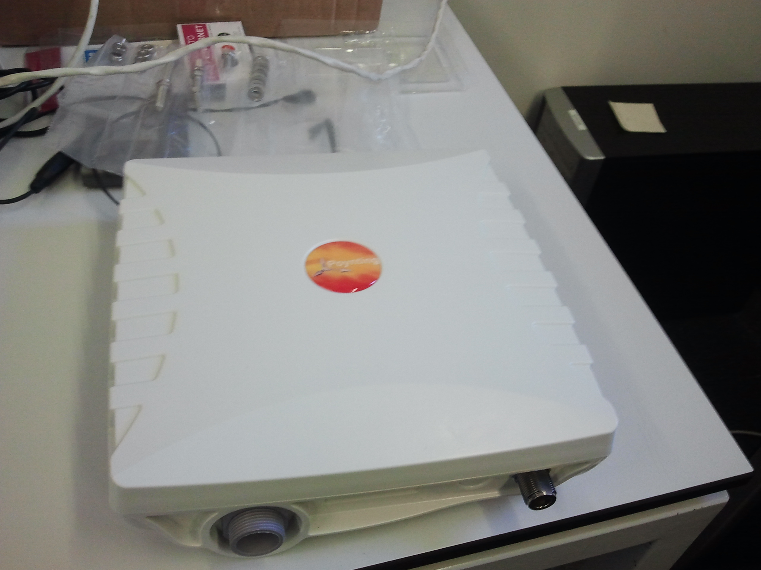

Box closing

Nota[1]

# Implementation

The following illustration shows a basic implementation of the Mobile Node with Alix antenna:

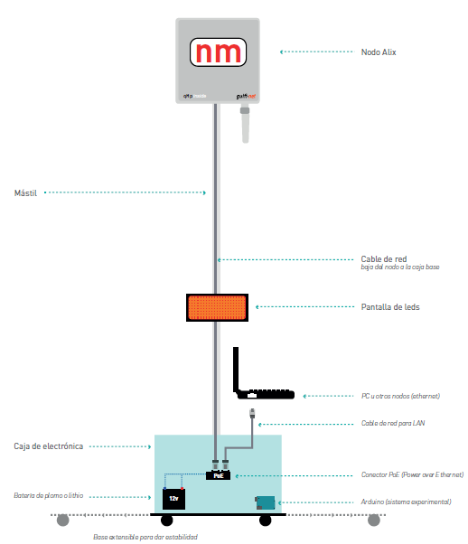

It is noted that we, basically, have the alix box fixed to a mast and connected to a battery. On the other hand, we have the LED screen that displays node status information and other relevant information using arduino and a PC that lets you quickly set the node.

With this implementation we will be able to offer coverage to a particular area by expanding an existing fixed network. A basic example of mesh network could be the following:



There is a fixed network composed for two antennas, thanks to our mobile node we can expand it and provide Wi-Fi connection to the final users.

# Configuration of the nodes

To download and compile the source code of QMP we have to follow these steps:

1. Download the source code from the repository:
   1. (Recommended) git clone git://qmp.cat/qmpfw.git qmpfw
   2. wget -c -q -O - "http://qmp.cat/gitrevision_download?project_id=7&rev=anonymous" | tar zxvf -
2. Go to the source folder:
   1. cd qmpfw
3. (Recommended) Make a “checkout” of the “testing” branch:
   1. make .checkout_qmp QMP_GIT_BRANCH=testing
4. Compile specifying the target node type:
   1. make build T=alix
   2. To see the available targets: make list_targets
   3. If you have more than one core in your processor you can execute: make build T=alix J=N, where N is the number of cores that you want to use.
5. Finally, you will be able to find the compiled image in the images/ folder.

## Nanostation M5

The steps to flash and configure the Nanostation M5 are the following:

1. Reset the device by pressing “reset” button during 10 second, until the lights start to flicker alternatively.
2. Install a tftp client, such as tftp-hpa.
3. We assign an Ip address to the wired connection of our PC within the 192.168.1.x/24 range.
4. From a terminal:
   1. tftp 192.168.1.20 (Defaul IP of the Nanostation)
   2. mode octet
   3. trace
   4. put *.bin (Image compiled previously)
   5. quit (Exit the tftp client)
5. Change the IP address to on belonging to the 172.30.x.x/16 range
6. We open a browser and go to http://172.30.22.1 or http://admin.qmp
7. We use user: root and password: 13f
8. We can now utilize the GUI of QMP.

## Rocket M5

We need to follow exactly the same steps that we followed with Nanostation M5.

## Alix 2D2

Once assembled and mounted into its box, we need to install the firmware in the flash card:

1. Connect the flash card to a PC with a card reader (internal or external).
2. We execute the command df -lh to see the drives list connected to the machine.
3. We identify the name associated to our flash card, for example /dev/sda
4. From the terminal we go to the folder where we have QMP firmware
5. We execute the command: if=firmware.bin of=/dev/sda, to dump the firmware to the flash card.
6. We execute the command: sync, to empty the buffers and make sure that there are not more pending operations.
7. We extract the flash card and insert it into the Alix board.
8. We switch it on and wait a reasonable time until the firmware is loaded.
9. Later, we should be able to access the GUI connecting an Ethernet wire and going to the following URL: http://172.30.22.1 (We do not need to configure any Ip since it is assigned with dhcp)

If it does not work, we will need to repeat the dump process since it is possible that an error occurred during the copy process.

# Basic features of the QMP interface

Below is a brief introduction to the main aspects of the interface qmp.

First, we have the welcome screen, where we will be asked for the username and password (U: root and P: 13f by default).

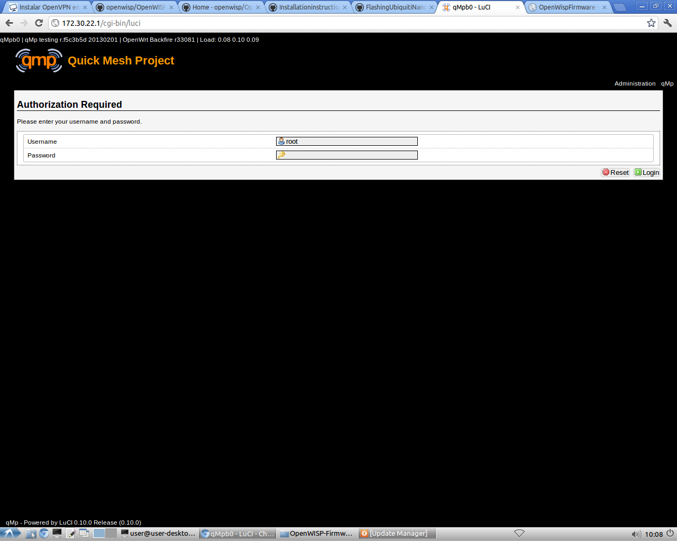

Once you have logged in, we can see the tabs: "Status", "Mesh", "Configuration", "Tools" and "About". We also have the option to access in "QMP" or "Administrator" mode, in the first we have only some basic options that we can control, but are sufficient for many cases. In the second, we have many more options than we can manage, and customize in a more detailed way.

## Status tab

It displays general system status: name, hardware model, firmware and kernel versions, memory status, etc. It is a purely informational tab, but it is very useful to get a general idea.

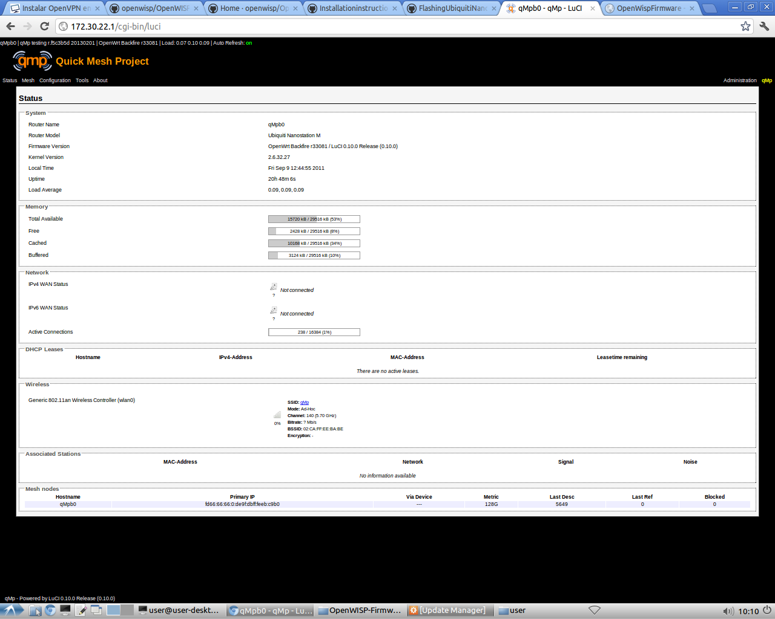

## Mesh tab

This tab displays the status of the mesh network. We can observe its current status, check what nodes belong to it, see the links established among them, see a visual graph of nodes and topology, etc.

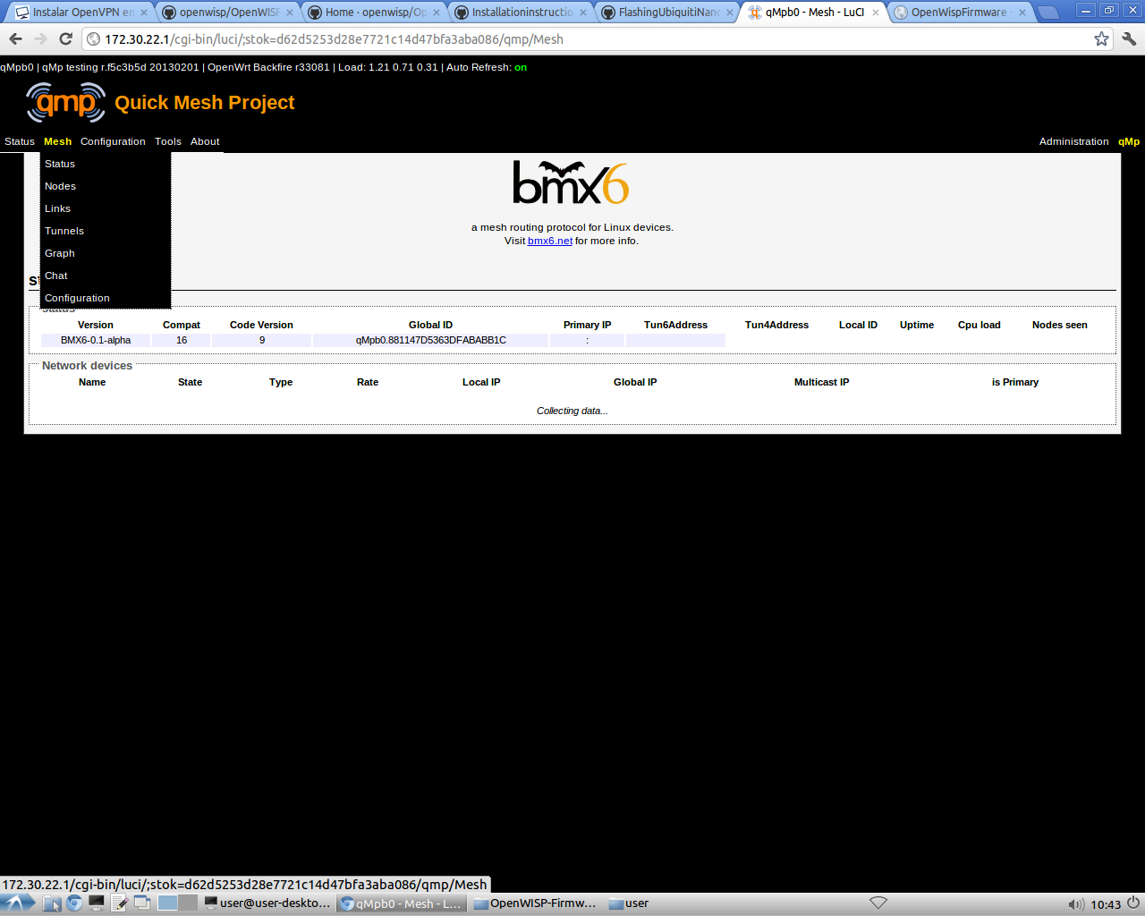

## Configuration tab

This tab allows to configure the network interfaces, the Wi-Fi, the node itself and to assign the appropriate parameter in every case.

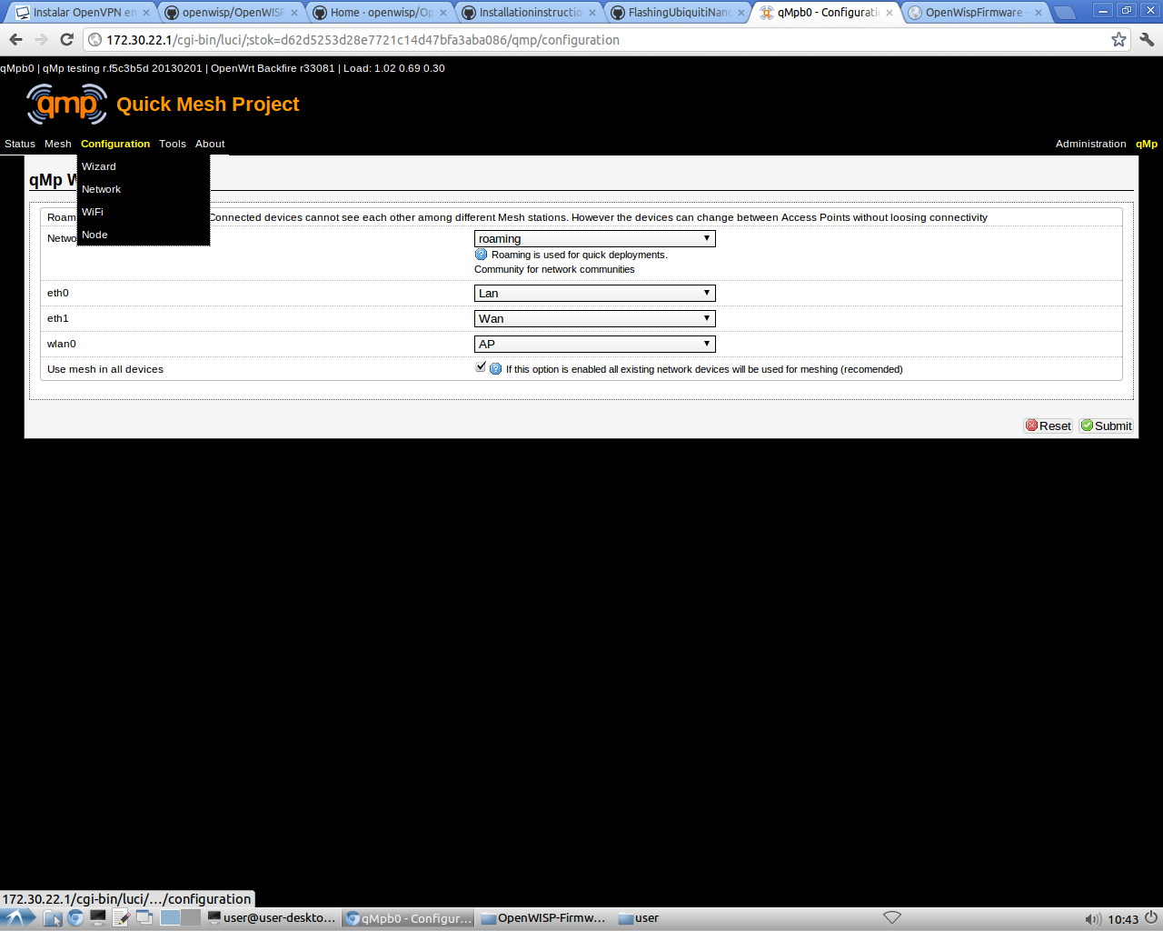

## Tools tab

It allows to configure the options, the splash screen, etc.

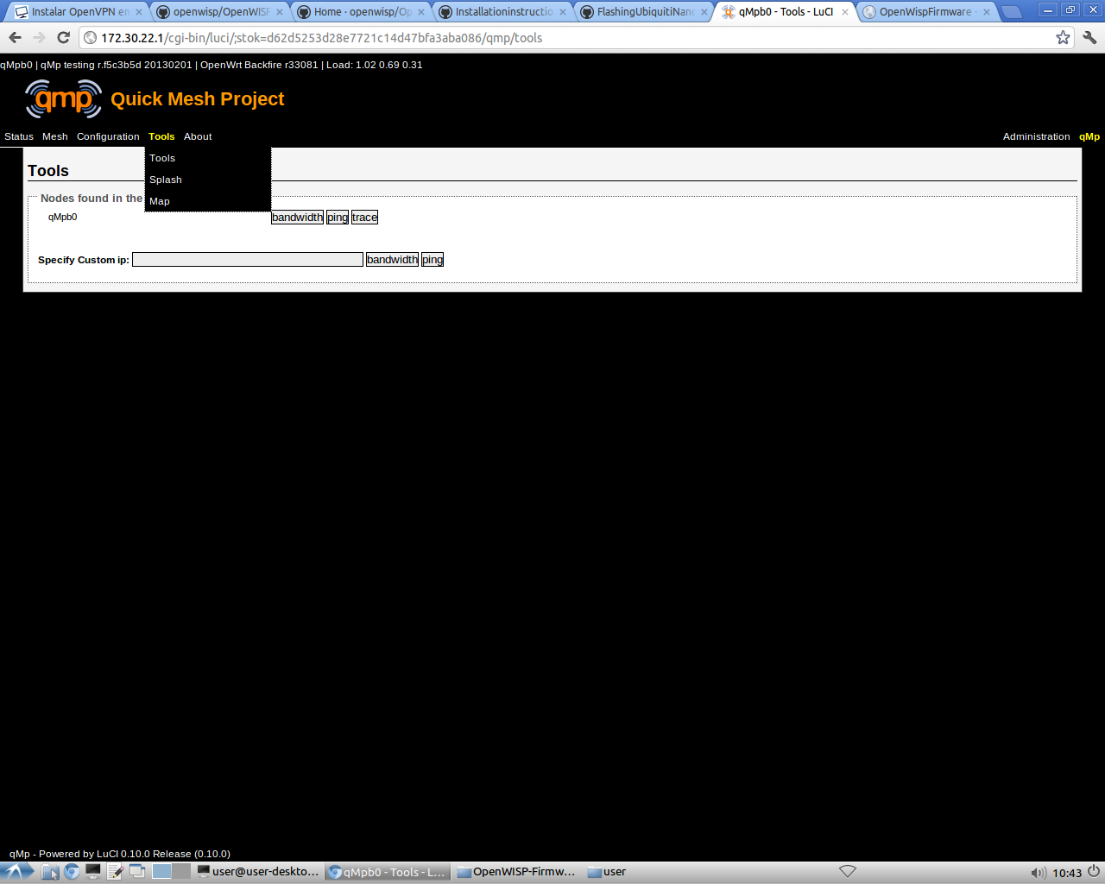

1. For more information see the video tutorial: http://vimeo.com/58127395